**INTRODUCTION**

**METHODTOLOGY**

**PROJECT OBJECTIVE**

**CONCLUSION**

The proposed study aims to design and develop a web-based application, iFinder, that addresses the challenges associated with the current lost and found management procedures for identification cards in Ghana. Specifically, the study aims to address the following issues:



**PRESENTATION ON IDENTIFICATION CARD FINDER**

**PRESENTED BY: TEAM IFINDER**

**THIS IS A PROJECT SUBMITTED TO THE DEPARTMENT OF COMPUTER SCIENCE, AUNIVERSITY OF GHANA, IN PARTIAL FULFIMENOF THE REQUIREMENTS FOR THE AWARD OF A BACHELOR OF SCIENCE DEGREE IN INFORMATION TECHNOLOGY**

1. **Inconvenient lost and found procedures**
2. **Lost and found information is scattered and unorganized**
3. **Failure to deliver the latest lost and found information to individuals**
4. **Financial loss**
5. **Restriction to facilities and services**

The iFinder will serve as a centralized platform for managing and organizing lost and found identification cards and delivering the latest information to the general population of Ghana. The application will be user-friendly and secure, and it will enhance the process of identifying and organizing lost and found identification cards, and provide an efficient solution to the problem of lost or stolen identification cards.

**PROJECT OBJECTIVE**

The proposed study seeks to design and develop a web-based application, iFinder, with the following objectives:

1. **To conduct a thorough evaluation of existing practices for Lost and Found Management Systems through observation and research.**
2. **To create an architectural design for the proposed Lost and Found Management System.**



**SMS to User**

**Rating**

**Founder Review**

**Admin Database**

**Comment**

**Cpanel Database**

**SMS to User**

**User Details**

**Home Page**

**Report Missing Card**

**Admin Database**

**Card Details**

**Cpanel Database**

**SMS to User**

**User Details**

**Report Found Card**

**Admin Database**

**Card Details**

**Cpanel Database**

1. **To implement a cross-platform Lost and Found Management System that offers a standardized and centralized approach for managing lost and found identification cards in Ghana.**
2. **To enhance the efficiency and effectiveness of managing and organizing lost and found identification cards in Ghana. The implementation of these objectives will assist in achieving the goal of creating a web application called iFinder that will offer a centralized system and assist people in reporting lost or stolen identification cards and helping to reach out to people whose ID cards have been found.**

Prototyping technique is the software development methodology employed in this project. The prototype methodology model is depicted in the image below.

The project design phase, iteration process, implementation, testing, and deployment are the four main stages that make up the prototype approach. In the section that follows, the specific tasks associated with each phase will be covered.

2. Planning Project

Plans were created during the project planning process. To guarantee that the project can be completed within the allotted time and scope, all project tasks were planned and scheduled. To define the project scope and depict the project timetable, the Work Breakdown Structure (WBS) and Gantt chart were created. In addition, a survey was carried out to gather the needs. The survey's analysis may be used to establish the software requirements and development tools.

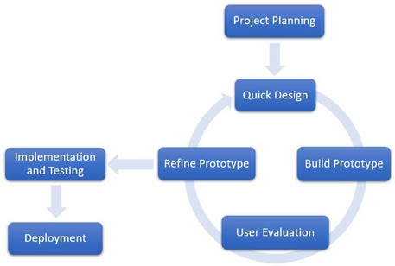

**PROCCESS FLOW**

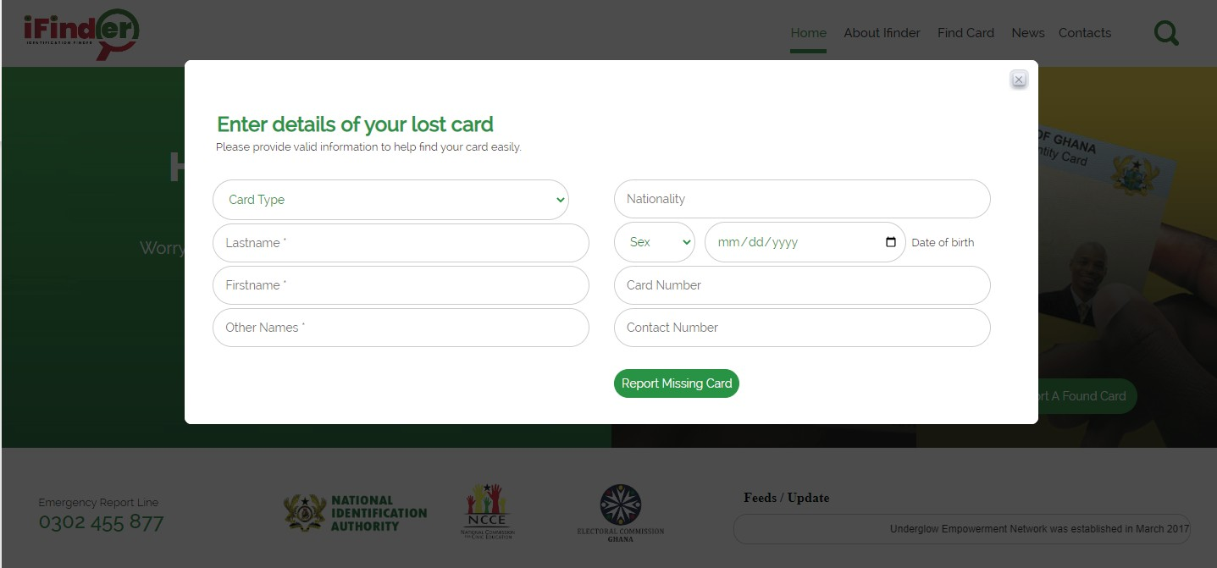

LThe proposed study seeks to design and develop a web-based application, iFinder, with the following objectives:

1. **To conduct a thorough evaluation of existing practices for Lost and Found Management Systems through observation and research.**
2. **To create an architectural design for the proposed Lost and Found Management System.**
3. **To implement a cross-platform Lost and Found Management System that offers a standardized and centralized approach for managing lost and found identification cards in Ghana.**
4. **To enhance the efficiency and effectiveness of managing and organizing lost and found identification cards in Ghana.**

The implementation of these objectives will assist in achieving the goal of creating a web application called iFinder that will offer a centralized system and assist people in reporting lost or stolen identification cards and helping to reach out to people whose ID cards have been found.

**PROJECT SCREENS**



To address these challenges, the study proposed the design and development of a web-based application, iFinder, that offers a centralized system for managing and organizing lost and found identification cards, and delivering the latest information to individuals.

The proposed solution includes a cross-platform application that allows individuals to use both web browsers or mobile devices to access lost and found information anytime, increasing efficiency. The centralization of information within the application will simplify the whole lost and found process and increase the efficiency of identifying and organizing lost and found identification cards.

The search and filter functions will help to improve the deliverability of lost and found information to individuals and increase the chances for the owners to claim back their items. The scope of the study was to design and develop the iFinder application and evaluate its performance on the Ghana population.

**REFRENCES**

*Ahmad, S., Ziaullah, M., Rauniyar, L., Su, M. and Zhang, Y., 2015. How Does Matter Lost and Misplace Items Issue and Its Technological Solutions in 2015 - A Review Study. IOSR Journal of Business and Management Ver . I, 17(4), pp.2319–7668.*

*Aldaej, R., Alfowzan, L., Alhashem, R., Alsmadi, M.K., Al-Marashdeh, I., Badawi, U.A., Alshabanah, M., Alrajhi, D. and Tayfour, M., 2018. Analyzing, Designing and Implementing a Web-Based Auction online System. International Journal of Applied Engineering Research, 13(10), pp.8005-8013.*

*Kaluža, M., Kalanj, M. and Vukelić, B., 2019. A comparison of back-end frameworks for web application development. Zbornik Veleučilišta u Rijeci, 7(1), pp. 317–332. Doi: 10.31784/zvr.7.1.10.*

*Nacheva. R., 2017. Prototyping Approach in User Interface. 2nd Conference on Innovative Teaching Methods, pp. 80-87.*

*Poe, L.F. and Seeman, E., 2019. An Empirical Study of Post-Production Software Code Quality When Employing the Agile Rapid Delivery Methodology. pp. 1-8.*





